**ADA BOOST AND XGBOOST**

**Business Problem** = ﻿﻿﻿﻿﻿﻿Perform AdaBoost and Extreme Gradient Boosting for the wbcd dataset.

* **Name of the File: -** wbcd.csv
* **Size of the File: -** 127 KB
* **Necessary Data : -** 569 Observations, 31 Features.

**Exploratory data Analysis** =

* **Outliers: -**  Outliers are not presents.
* **Missing Value: -** Data don’t have Missing Values
* **Output:** - Categorical
* **Sampling:**- Stratified Sampling (63% - 37%)

**Ada Boosting =**

* **﻿Criterion:-** Entropy
* **Base of ﻿Estimators: -** Decision Tree
* **No. of ﻿Estimators:-** 300
* **﻿Learning Rate:-** 0.9
* **Accuracy Score Train:-** 100 %
* **Accuracy Score Test:-** 99%
* 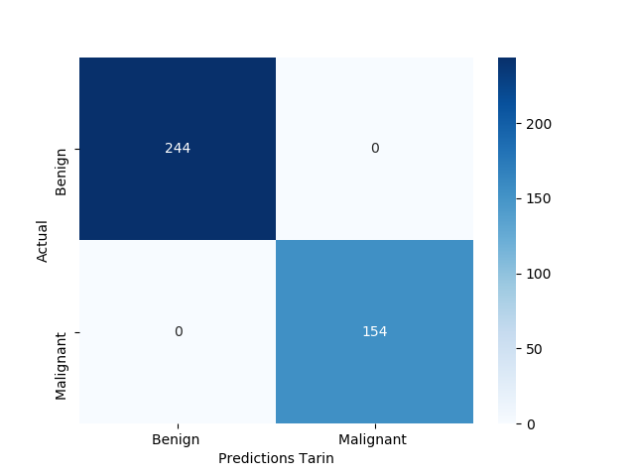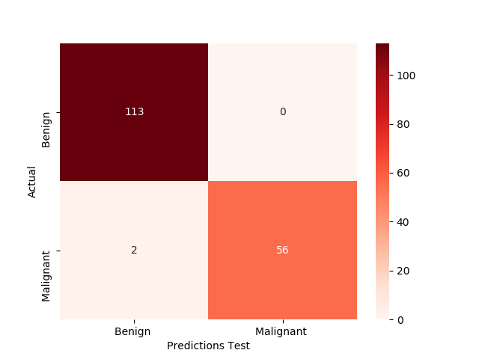**Confusion Matrix : -**

Accuracy of model on Train and Test Data is High. Let’s try ﻿Extreme Gradient Boosting.

**XG Boosting =**

* **﻿﻿Max Depth:-** 6
* **No. of ﻿Estimators:-** 350
* **﻿Learning Rate:-** 0.08
* **﻿Sub Sample:-** 1
* **Accuracy Score Train:-** 100 %
* **Accuracy Score Test:-** 98%
* 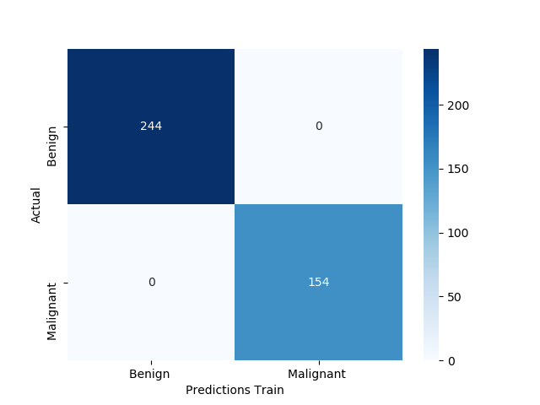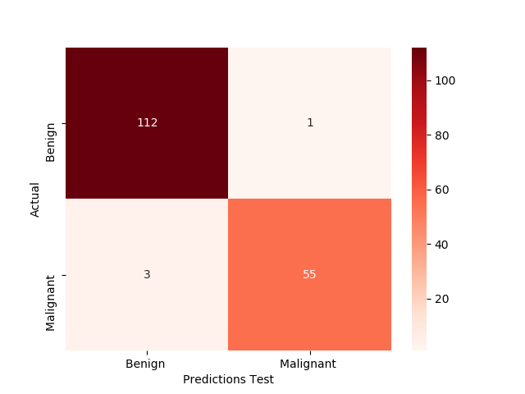**Confusion Matrix : -**

Accuracy of model on test data is slightly lower as compare to Ada Boost. We can use this model for predication

* 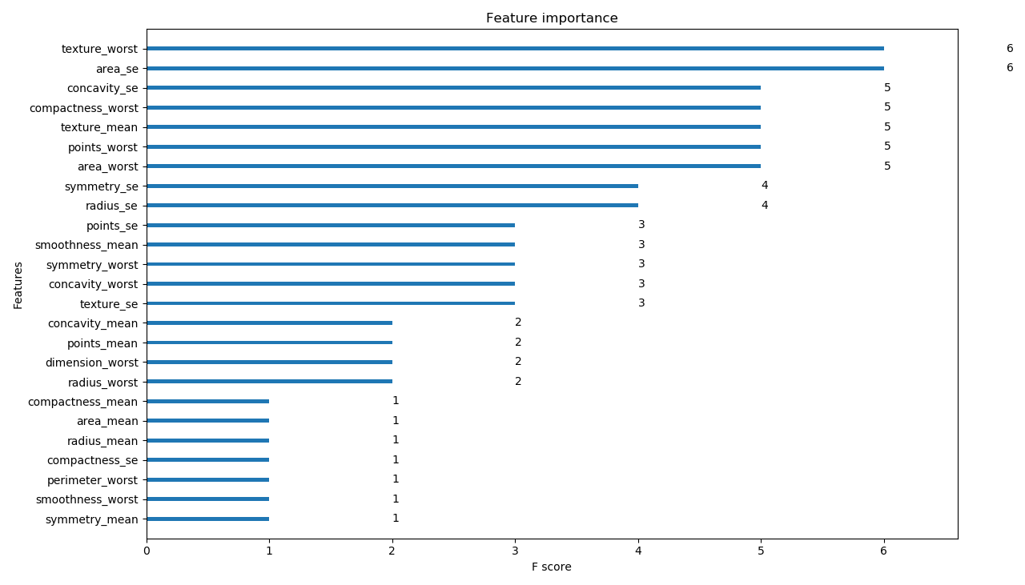**Important Feature Plot:-**

**Python code file**: - [WBCD Analysis.py](https://github.com/nilaydeshmukh0/AdaBoost-XGBoost/blob/master/WBCD%20Analysis/WBCD%20Analysis.py)